Figure S1

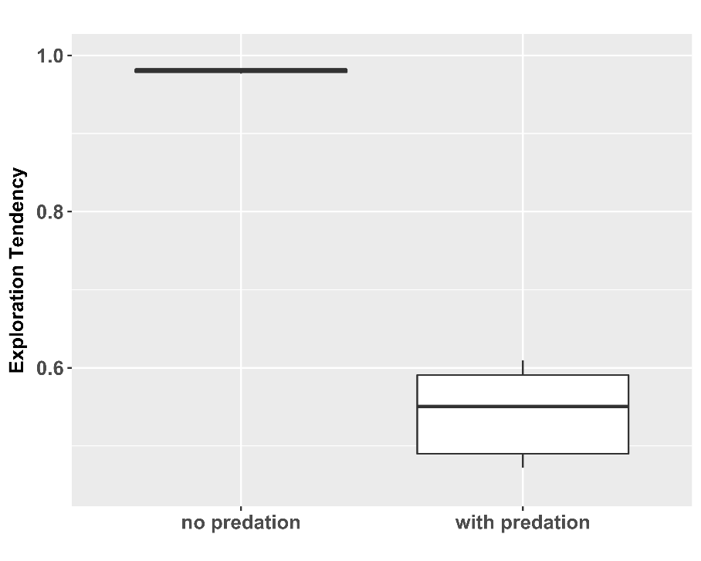

Figure S1: Predation prevents the emergence of fast exploration strategy
Each boxplot is based on 10 replicate simulations with N = 1000 and G = 500; D_{R1} = 0.0 and D_{R4} = 0.0; T = 200. The only difference in parameter setting is predation.

Figure S2

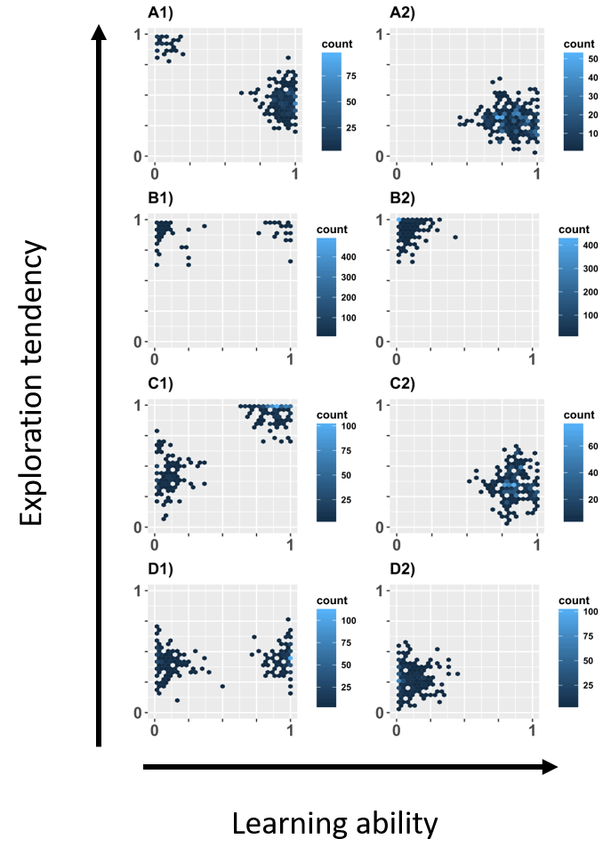

Fig. S2: Predation hinders co-existence
Each panel shows the result of one simulation as an example from 10 replicate runs. In each figure pair (e.g. A1 and A2 etc.) left hand panels show the results of simulations without predation. Corresponding right hand panels show simulations with otherwise identical setting but with predation. Conditions between different pairs (i.e. A, B, C, and D) vary in resource detectability (D_{R}) and season length (T). Predation can hinder co-existence of cognitive styles in multiple ways. For example, by making fast exploration and slow learning strategies (A) or fast exploring and fast learning (B) less beneficial. In C) a slow learning strategy becomes less adaptive, as slow learners are not able to learn sufficiently to reduce lethality of predators. In D) even fast learning is not enough to reduce predation sufficiently and fast learning styles are prevented. Settings: A: D_{R1} = 0.0 and D_{R4} = 0.9; T = 150; B: D_{R1} = 0.0 and D_{R4} = 0.0; T = 20; C) D_{R1} = 0.9 and D_{R4} = 0.0; T = 200; D) D_{R1} = 0.9 and D_{R4} = 0.9; T= 45.

Figure S3

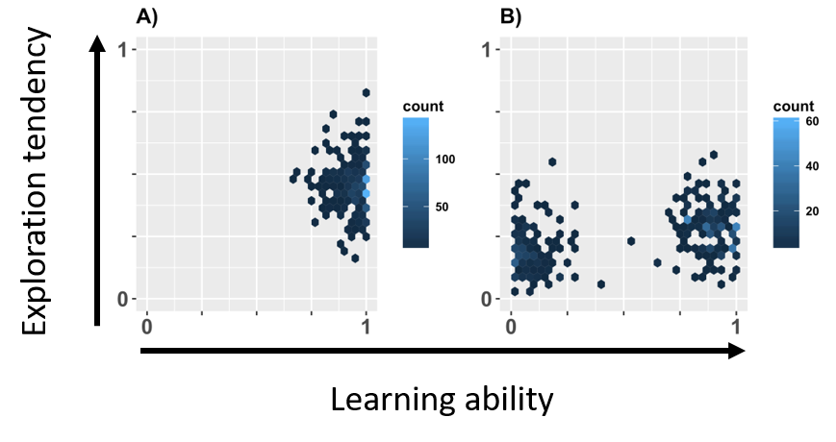

Figure S3: Predation can also induce co-existence
Results for simulations A) without predation and B) with predation. All other parameter settings were identical. Both panels show the result of one simulation as an example from 10 replicate runs. All replicate runs produced qualitatively similar results, with one exception: in one out of ten runs in B), the co-existence collapsed due to the extinction of the fast learning strategy, which was likely caused by a combination of stochastic events and high predation pressure. Settings: D_{R1} = 0.9 and D_{R4} = 0.9; T = 110.

